**USING RAPTOR – SWAP TWO CHARECTERS**

**FLOWCHART**

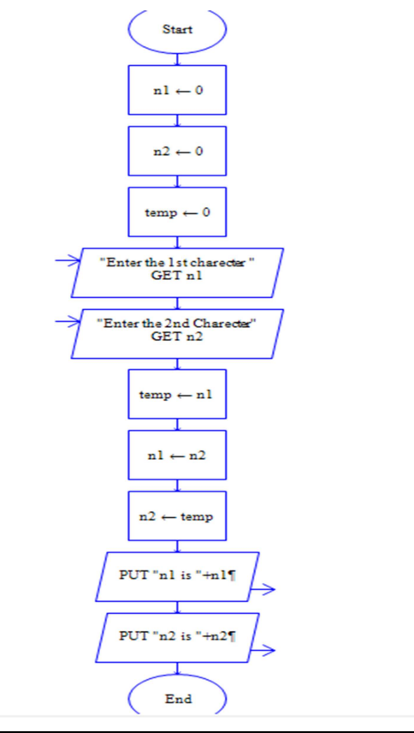

**OUTPUT**

INPUT

N1 =V

N2 = R

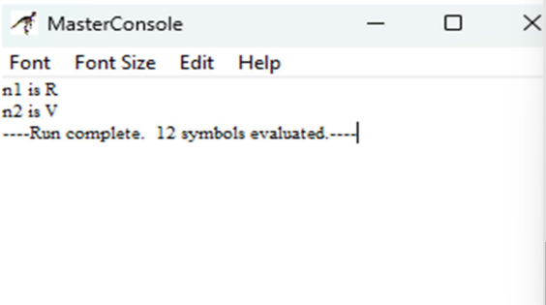

**RESULT:**

The program is executed and verified successfully